Tinsae Gebriel
Professor Leah Brooks
PPPA6017
November 15, 2016

The Impact of California’s Proposed Tobacco Tax

Introduction
The state of California is proposing to levy an excise tax on tobacco products. Excise taxes are taxes levied only on certain goods. The new legislation, Proposition 56, would impose a 2-dollar excise tax on cigarettes, tobacco products, and electronic cigarettes in order to curb tobacco use and generate revenue for the state’s healthcare program for low-income residents (Legislative Analyst’s Office, 2016). This memo analyzes the effect this tax would have on the current demand for cigarettes among Californian smokers. It’s anticipated that producers and consumers would share the $2 dollar tax burden. Therefore, smokers would be paying more for a pack of cigarettes and producers would be earning less for a pack of cigarettes. As a result, cigarette consumption would decrease but there would still be demand that would generate some revenue for the state’s healthcare program.

Policy Background
California currently imposes a $0.87 excise tax on cigarettes packs. Proposition 56 would add 2 dollars to the current tax. Thus, the proposed excise tax on a pack of cigarettes would be $2.87 (Legislative Analyst’s Office, 2016). Proponents of this proposition anticipate that this tax would accumulate enough revenue to fund the state’s healthcare program for low-income Californians. However, the revenue that could be derived from this increased tax is based on how the tax is distributed between cigarette companies and smokers, and also the price elasticity of demand of cigarettes.

Methodology
In order to determine the new demand of cigarette packs under Proposition 56, we need to determine the following:
- The current average price of a pack of cigarettes in California (P_{o)}
- The new price of a pack of cigarettes after the proposed tax (P_{n)}
- The current demand of cigarettes (Q_{o)}
- The price elasticity of demand of cigarettes
Calculations
- As of 2015, the average price of a pack of cigarettes in California was estimated as $5.89. This estimate includes the current $0.87 excise tax and a 7.5% sales tax that is added on all purchases (Fair Reporters, 2015).
- In order to determine the new price of cigarettes, we need to determine how the $2 tax burden would be shared between tobacco companies and smokers. It is unlikely that the burden of the tax would be passed on to consumers or producers solely. The proposed tax would shift the supply curve inward by the amount of the tax but the price would not increase by that amount [See Fig. 1]. Since it is uncertain how the tax burden would be shared, we will estimate three new prices of cigarettes [see Fig. 2].
  - In the first estimate, producers bear the majority of the tax burden. Majority tax burden is defined as 2/3 of the $2 excise tax. If tobacco companies bear the majority of the tax burden, the new price of cigarettes would be $7.04.
  - In the second estimate, consumers bear the majority of the tax burden and the new price would be $7.76.
  - In the last estimate, consumers and producers share the tax burden equally. Under this scenario, a pack of cigarettes would cost $7.41.
- According to the Center for Disease Control and Prevention’s (CDC) most recent data, cigarette use among adults in California is between 9.7% and 13.6% (Center for Disease Control and Prevention, 2014). It’s estimated that 871 million packs of cigarettes were sold between 2013 and 2014 (Willion and Mason, 2014). Based on market equilibrium principles, we could conclude that at the current price of $5.89, cigarette consumption is 871 million packs [See Fig. 3].
- Due to its addictiveness, tobacco has historically been portrayed in literature as a relatively inelastic good. In 1995, Theodore Keeler and colleagues estimated the price elasticity of demand of cigarettes for California smokers as -.46 (Keeler et al, 1995). In another study, Badi Baltagi and Rajeev Goel of the Journal of Economics and Finance analyzed 336 state cigarettes taxes over 42 years from 1956-1997 to determine the effect of taxes on cigarette demand. Baltagi and Goel calculated the median price elasticity of demand of cigarettes in the U.S. as -.32 (Baltagi and Goel, 2004). Due to this variance in estimates, Craig Gallet and Josh List conducted a meta-analysis study of 86 empirical studies and estimated the price elasticity of demand as -.40 in the short run and -.44 in the long run (Gallet and List, 2003). However, in a more recent working paper, John Tauras and colleagues of the National Bureau of Economic Research analyzed state level cigarette price data from 1991-2012 and estimated the average elasticity of demand as -.73, suggesting that smokers have become more responsive to price (Tauras et al, 2016).

Results

Since the price elasticity of demand of cigarette varies, we are going to estimate two possible quantities of cigarettes demanded under Proposition 56 for each new price (P_{n}). We’re going to use -.32 as the low elasticity estimate, where consumers are inelastic to price change and -.73 as the high estimate, where consumers are more responsive to price change. Using the lowest and highest elasticity estimates will give us a range in which the true quantity demanded could fall under Proposition 56 [See Fig. 4]. We will use the equation below to calculate the new quantity of cigarette packs.
$$E^{D}=\frac{\frac{Q_{n}-Q_{o}}{Q_{o}}}{\frac{P_{n}-P_{o} }{P_{o}}}$$
When producers endure the majority of the proposed tax, the new quantity of cigarettes demanded could fall between 747 million packs and 817 million packs. When the tax burden is equally shared between consumers and producers, the new quantity demanded could fall between 707 million packs and 799 million packs. Lastly, if consumers bear the majority of the tax burden, the new quantity demanded could fall between 699 million packs and 782 million packs of cigarettes.

Conclusion
Based on the results, the demand of cigarette packs under Proposition 56 would decreases, regardless of who bears the burden of the tax. However, when the majority of the tax burden is passed on to the consumers, we will see the greatest decrease in the demand for cigarettes. Ultimately, it is important that proponents of Proposition 56 understand that two factors will impact the new demand for cigarettes: 1) consumer’s share of the $2 tax burden and 2) how responsive smokers are to price changes.
Even though demand decreases, there would still be consumers and producers in the market that would generate funds from the proposed tax. Therefore, Proposition 56 would accomplish both of its intended goals: reducing tobacco use and generating revenue for the state low-income healthcare program.

Appendix

Fig 1: The New Market under Proposition 56
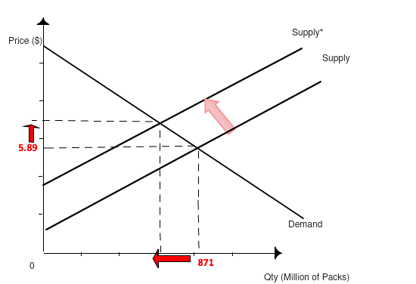
$2 Tax

Fig 2: Tax Burden

Burden | Calculation  (P_{o}+ %tax) * sales tax | New Price
P_{n1}: Producer has majority burden | (5.89 +2(1/3)) $×$ 7.5% | $7.04
P_{n2}: Consumer has majority burden | (5.89 + 2 (2/3)) $×$ 7.5% | $7.76
P_{n3}: Tax burden equally shared | (5.89 + 2(1/2)) $×$ 7.5% | $7.41

Fig 3: The Current Market
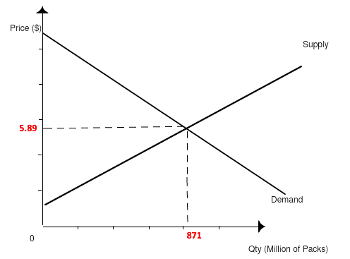

Fig 4: All Possible New Quantities Demanded

Elasticity | New Prices
 | $7.04 | $7.41 | $7.76
-.32 | 817 million packs | 799 million packs | 782 million packs
-.73 | 747 million packs | 707 million packs | 669 million packs
Bibliography

Baltagi, Badi and Rajeev Goel. 2004. State Tax Changes and Quasi-Experimental Price Elasticities of U.S. Cigarette Demand: An Update. Journal of Economics and Finance. 28 (3): 422-429.

Center for Disease Control and Prevention. 2014. Current Cigarette Smoking Among Adults in the United States. U.S. Department of Health & Human Services. http://www.cdc.gov/tobacco/data_statistics/fact_sheets/adult_data/cig_smoking/ (accessed October 15, 2016).

Fair Reporters. 2015. Prices Of Cigarettes By State. http://fairreporters.net/health/prices-of-cigarettes-by-state/ (accessed October 15, 2016).

Gallet, Craig and John List. 2003. Cigarette Demand: A Meta-Analysis of Elasticities. Health Economics. (12): 821-835.

Hu, The-Wei, Ren, Qui-Feng, Keeler, Theodore, and Joan Bartlett. 1995. The demand for cigarettes in California and behavioural risk factors. Health Economics. 4 (1): 7-14.

Legislative Analyst’s Office. (2016). Propositions. http://www.lao.ca.gov/BallotAnalysis/Propositions?date=November+08%2C+2016&propNumber=56&searchTerm (accessed October 15, 2016).

Tauras, John, Pesko, Michael, Huang, Jidong, Chaloupka, Frank, and Mathew Farrelly. 2016. “The Effect of Cigarette Prices on Cigarette Sales: Exploring Heterogeneity in Price Elasticities at High and Low Prices.” The National Bureau of Economic Research. Working Paper 22251.

Willon, Phil and Melaine Mason. 2014. California health and child-welfare agency may seek increase in tobacco tax. Los Angeles Times, November 19. http://www.latimes.com/local/politics/la-me-pol-tobacco-tax-20141120-story.html

